**Welcome to Module 10**

Welcome to the "Building Python Packages" category, where you'll learn how to create and distribute your own Python packages through PyPi (Python Package Index) so everyone can install your package using "pip." We will use the code of one of the apps we build during the course to create our own package.

Let's dive in!

Remove hard coding

Make a module

import setuptools into setup.py and write setup file

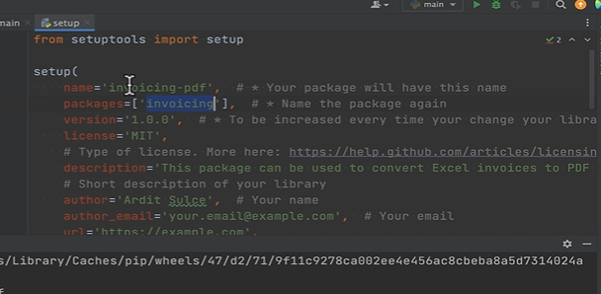



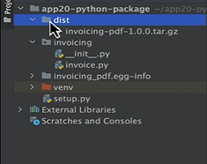

twine

